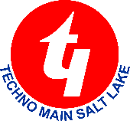
TECHNO INDIA MAIN SALT LAKE

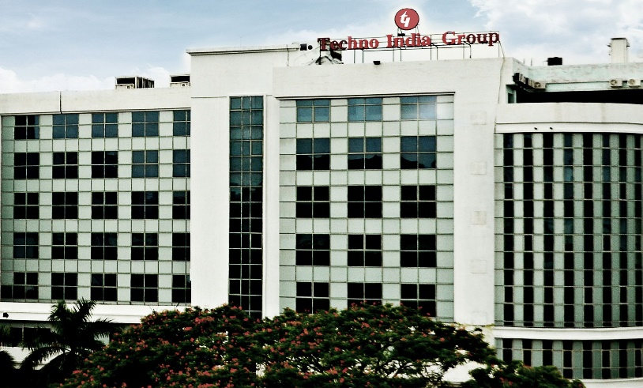

Techno India, located in Salt Lake, Kolkata, is one of the premier institutions for technical education in India. Established in 2000, it has carved out a reputation for offering top-quality undergraduate and postgraduate courses in engineering, management, and applied sciences. The campus, nestled in the IT hub of Salt Lake, provides a dynamic and nurturing environment for students who are aspiring to build successful careers in the fields of technology and business.The primary aim of Techno India is to provide comprehensive education and skill development through innovative teaching methodologies, state-of-the-art infrastructure, and an ever-evolving curriculum that keeps pace with the latest trends in the industry. The institution is affiliated with Maulana Abul Kalam Azad University of Technology (MAKAUT), West Bengal, and offers a variety of programs such as B.Tech, M.Tech, MBA,Diploma and more. These programs are designed to impart both theoretical knowledge and practical skills, preparing students for the challenges of the modern-day job market.The campus of Techno India Salt Lake is equipped with modern amenities, including well-furnished classrooms, laboratories, libraries, and hostels. The institution provides an atmosphere conducive to learning and creativity, with access to cutting-edge technology. The computer and engineering labs, for example, are equipped with the latest software and hardware tools, allowing students to work on live projects and gain hands-on experience. The institution encourages students and faculty alike to engage in research activities, fostering a spirit of innovation and intellectual curiosity. Several research publications, workshops, and seminars are regularly held to keep the academic community up to date with the latest developments in the field .The faculty at Techno India is highly experienced and qualified,with many of them holding advanced degrees from prestigious institutions.
END

